Computer Language Coding Concepts

System Interface Command Call Notation
One of the notations for system command calls is calling upon the command definition in the system interface:

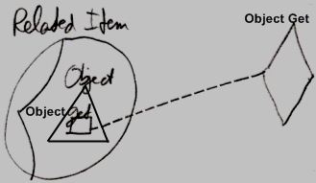

This however requires the system interface to be shown. Then there is the question whether to show the other members of the system interface as well, or only to show the members of the system interface, that are actually called.

There are other options for displaying a call to a system command that are laid out in the articles that follow.

Author & Copyright: Jan-Joost van Zon Date: August 31, 2009 – August 31, 2009 Location: Oosterhout, The Netherlands Status: Finished

